ANIM1802 Critical Studies
Thom Kent P2520360
Module Leader: Jamie Lochhead
Lab Tutor: Jamie Lochhead

How would Honey Island conform to genre expectations?

Contents
Introduction 3
Cinematography 3
Motifs 6
Audio 7
Conclusion 8

Figure 1:Wide shot taken from How the West Was Won (Ford, 1962) 2
Figure 2: Still taken from the opening of The Shining (Kubrick, 1980) 3
Figure 3: Still taken from Once Upon a Time in the West (Leone, 1968) 4
Figure 4:Still from a duel sequence (Leone, For a Few Dollars More, 1965) 5
Figure 5: Still from Appaloosa (Harris, 2008), showing the hero defeating a lesser character while wearing a wide-brimmed hat 6

Introduction
Honey Island is envisioned to be a cross-genre production, taking elements from Western and Horror pieces and combining them together in ways that synergize, overall lifting the main production. This will be done mainly by utilizing a Western-esque setting to tell a Horror-esque plotline.

Cinematography
One way the lines between the genres can be blurred in this case is via cinematography. For example, many Western productions use wide establishing shots of vistas, valleys or other landscapes which may be relevant to the plot.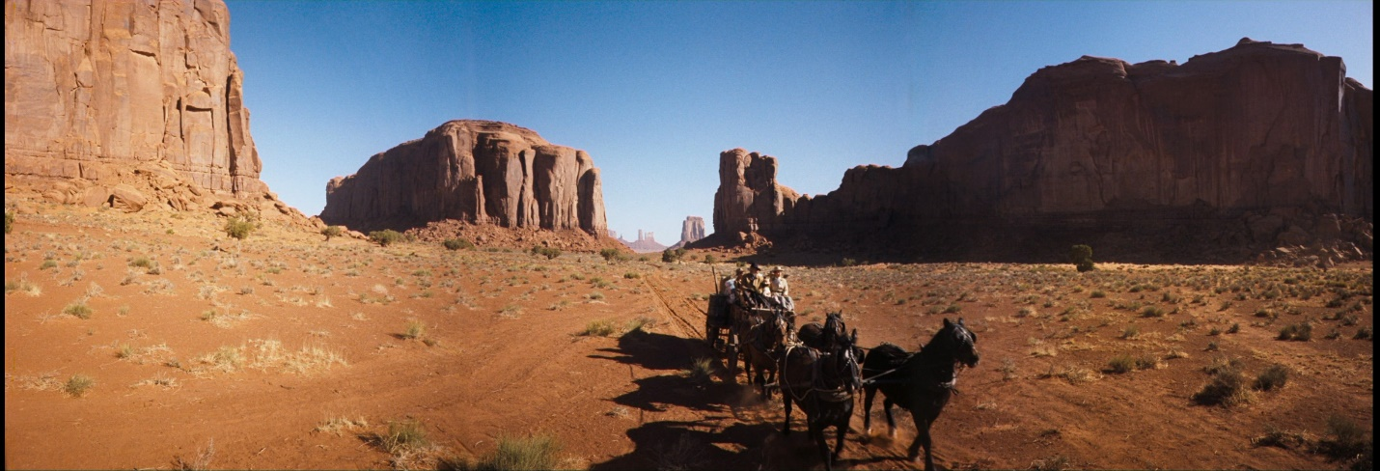
Figure 1:Wide shot taken from How the West Was Won (How the West Was Won, 1962)
These shots utilize scale in such a way that ensures characters appear miniscule in comparison to their environment. The Frontier is show as vast and overpowering, accentuating character’s bravery by showing their willingness to accept the risks that come along with traversing it. One such risk stems from isolation – a classic horror trope. From here, comparisons can be made to establishing shots from horror films, such as those used in The Shining (The Shining, 1980).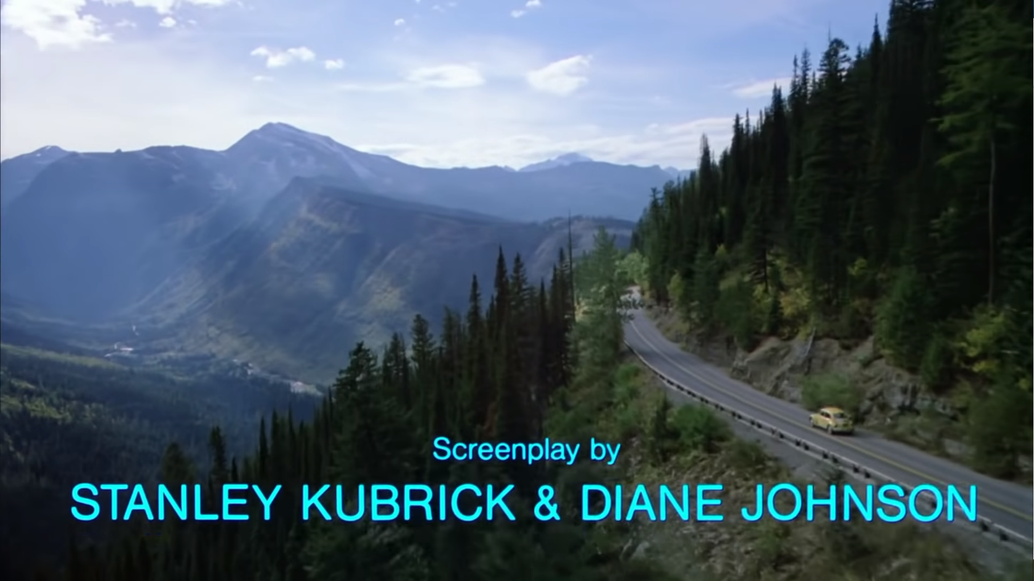
Figure 2: Still taken from the opening of The Shining (The Shining, 1980)
Akin to the wide shots in Westerns, these shots show the settings of the film in such a way that the scale differential between characters and their surroundings is accentuated. Where a Western would use this differential to show bravery, however, a Horror would use it to show isolation; the characters are cut off from society, meaning there will be no other people around to aid them when they befall their inevitable fate. Along with these, a Western would most likely accompany this type of shot with somewhat triumphant music, exemplifying the determination of its characters audibly. However, a Horror would be more likely to accompany it with menacing music, in order to build tension, in anticipation for the dangers that await its characters in their setting. This shows how the genres could easily be melded with these wide shots: take the visual aspects of a wide Western shot, but contextualize it as a Horror shot i.e. shooting a wide shot of a vista (or in the case of Honey Island, the Louisiana Bayou), but framing it as a Horror shot by shooting at dusk or night and accompanying the shot with malevolent-sounding music.
Another way these genres can be made to meld cinematographically is via ‘duel’ shots. Westerns utilize multiple kinds of ‘duel’ shots, with two major shots – the side-on duel shot and the medium shot, taken from behind a duelist. The first of these is one that has little to no use in Horror productions, but has the potential to be co-opted for use in a Horror context. 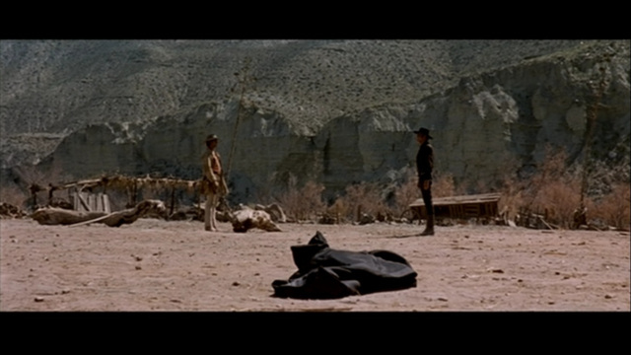
Figure 3: Still taken from Once Upon a Time in the West (Once Upon a Time in the West, 1968)
Shots like this are used to build tension, namely as to which of the duelists will win the duel. However, it is the framing of the shot which can be repurposed for Horror; the focal point of the shot is the two duelists and them facing one another implies opposition, showing that the two are enemies, staring each other down. A Horror context can play on this by removing one of the duelists. One of the most played on fears in Horror is that of the unknown. Horror pioneers have played with this fear for decades, with quotes like “The oldest and strongest emotion of mankind is fear, and the oldest and strongest kind of fear is fear of the unknown” (Lovecraft, 1927) being taken as gospel for the years to come after their publishing. Said fear can be utilized here by, as aforementioned, removing a duelist. The emptiness on one side of the frame acts to imply that an opponent should be present, but is not, having yet to reveal themselves. This leaves the audience wondering about both the nature and the location of the opponent, building tension as to what may unearth itself to take the place of the second duelist. This could be used to either elude to or show the reveal of Letiche in Honey Island, perhaps even both.
The second, and most well-recognized, duel shot is the medium shot from behind a duelist. 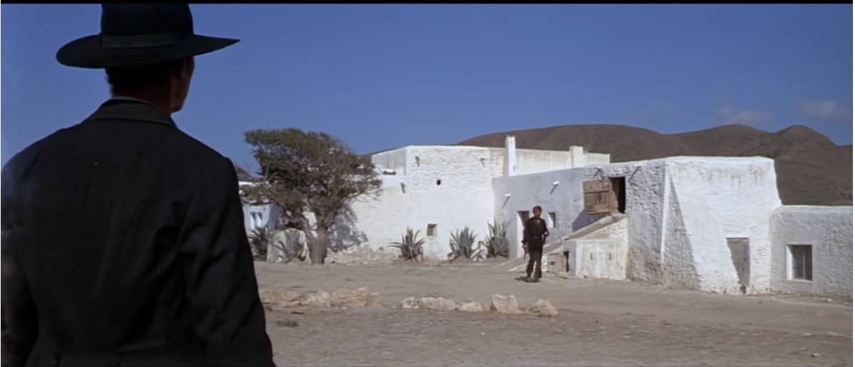
Figure 4:Still from a duel sequence (For a Few Dollars More, 1965)
The dynamic of this shot is similar to the aforementioned duel shot, but also makes use of a power dynamic via on-screen scale. Although it is clear to the audience that one duelist is further from the camera than the other and that does not necessarily pertain to their actual size, the fact is the same that one duelist is larger on-screen than the other, thereby invoking a sense of superiority from the closer duelist. To flip this into a horror context for Honey Island is simple- ensure that the monster, Letiche, takes the place of the duelist closer to the camera. Using this to enforce the power dynamic between the monster and the protagonist (i.e the monster is exponentially more of a threat to the protagonist than vice versa) would aid in solidifying the sense of impending doom invoked by the monster’s presence. A bonus to this is that the shot could be used to unveil part of the monster’s form, giving the audience a small amount to work with in envisioning it themselves, but not enough to lift off the ‘fear of the unknown’ aspect of the scenario.

Motifs
The motifs of Westerns are exemplified in most any Western film. The most recognizable of these are shown via characters, namely those that “wear Stetson hats, bandannas, spurs, and buckskins [and] use revolvers or rifles as everyday tools of survival” (Wikipedia, n.d.). Honey Island’s protagonist, Adrian Grouse, is a bounty hunter, so would likely fit this description well. However, there are certain parts of the stereotypical outfit which would be better suited to be changed. For instance, Stetson-style hats are often worn in Westerns by characters with a certain stature, be it the protagonist or the antagonist. Due to this, they are somewhat indicative of a character’s threat level – skilled gunslingers almost always wear Stetsons, due to the hats making them appear wider and thereby more imposing, but unskilled combatants are most always wearing either narrower-brimmed hats or no hats at all.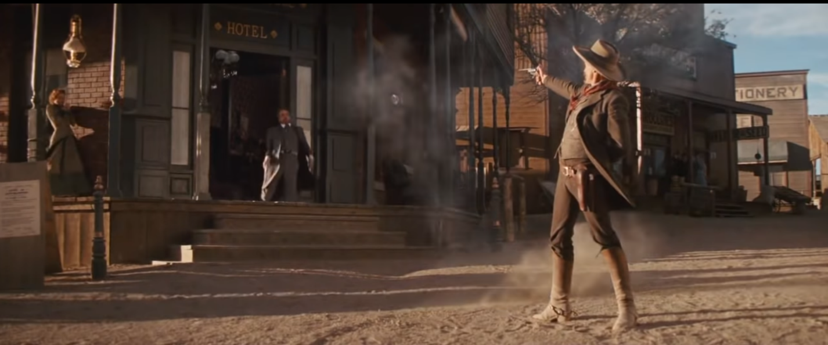
Figure 5: Still from Appaloosa (Appaloosa, 2008), showing the hero defeating a lesser character while wearing a wide-brimmed hat

Playing with the relative threat level of characters is a Western element that translates very well to horror pieces – for instance, in Honey Island, initially depicting Grouse with a Stetson would make him appear to the audience as a capable bounty hunter that can handle himself in the face of adversity. Him then losing that hat works as a sign of powerlessness – his loss of the apparel that makes him appear more imposing shows his transition from predator to prey in the face of his new enemy.
Similarly, weapons are well-known motifs of the Western genre. Combatants use revolvers, repeating rifles and double-barreled shotguns in battle, as well as bladed melee weapons in some cases. Weapons are also used in horror films to some degree – but not in the same way. Where a gun would be a symbol of a characters threat and potential to harm their enemies in a Western, Horrors mostly use them to accentuate hopelessness by having guns fail, either by jamming or running out of ammunition. Considering that it is highly likely a Western bounty hunter would carry a firearm, this would make for an effective means of accentuating the power dynamic between Grouse and Letiche in Honey Island. Grouse’s weapon becoming waterlogged or his loss of his ammunition supply would make for a believable way to further depict him as defenseless against his aggressor.

Audio
Westerns and Horror films also use one thing in a somewhat similar way- silence. Silence or the reduction of noise levels to a very low point are used in both films styles to build tension. Westerns mainly invoke silence for duel sequences, allowing the viewer to mentally stew in their predictions and self-doubt of those predictions. However, in this kind of scene, the outcome is more predictable than that of a Horror sequence utilizing silence, which gives the viewer a much wider range of possibilities in terms of outcome generally, especially due to the prolific nature of fakeouts in Horror. To meld the two uses of silence, a Western-esque image in what has been contextualized as a Horror scene would be shown, a prime example being the aforementioned duel sequence.

Conclusion
In conclusion, Honey Island’s production aims to create a fusion of two classic genres by identifying the points in which the two synergize. Horror films thrive from the effective use of tension, as do the most memorable scenes from Western productions. Techniques such as the aforementioned cinematography are used in both for this very reason, although uses in either are contextually distinct in their execution. Due to crossovers in technique like this, and the lack of films spanning the two genres, the Western-Horror fusion genre is one that could be regarded as an untapped goldmine in terms of filmmaking potential. This could be down to the use of generally similar characters that play largely into stereotypes in both genres, and the potential for the stereotypes in action from one genre to take away from the other’s role in a given sequence. For Honey Island, this could be avoided by depicting Grouse as a strong character who is still human in his fear, perhaps comparable to Ellen Ripley of Alien (Alien, 1980) fame. This evades the stereotypes of the brooding bounty hunter or the cocky, overdramatic teen by finding a middle ground. The combination of this, along with the rest of the content of this essay, should help Honey Island theoretically carve out its own defined space in both the Western and Horror genres.

Bibliography
Alien. 1980. [Film] Directed by Ridley Scott. s.l.: s.n.
Appaloosa. 2008. [Film] Directed by Ed Harris. s.l.: s.n.
For a Few Dollars More. 1965. [Film] Directed by Sergio Leone. s.l.: s.n.
How the West Was Won. 1962. [Film] Directed by John Ford. s.l.: s.n.
Lovecraft, H., 1927. Supernatural Horror in Literature. The Recluse.
Once Upon a Time in the West. 1968. [Film] Directed by Sergio Leone. s.l.: s.n.
The Shining. 1980. [Film] Directed by Stanley Kubrick. s.l.: s.n.
Wikipedia, n.d. Western (genre). [Online]
Available at: https://en.wikipedia.org/wiki/Western_(genre)

